WEEK 2
Exercise 1: Configuring a Basic Spring Application
Scenario:
Your company is developing a web application for managing a library. You need to use the Spring Framework to handle the backend operations.

src/main/java/com/library/repository
BookRepository.java
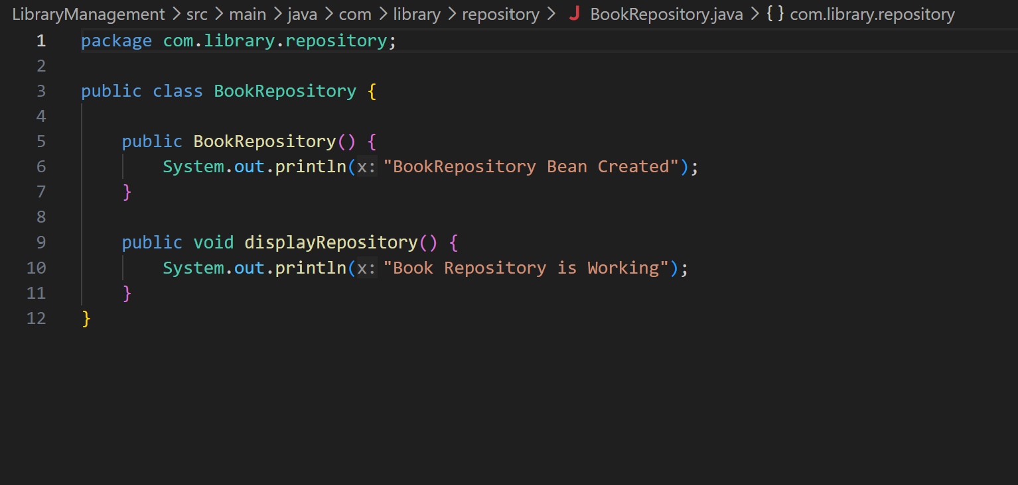

src/main/java/com/library/service
BookService.java
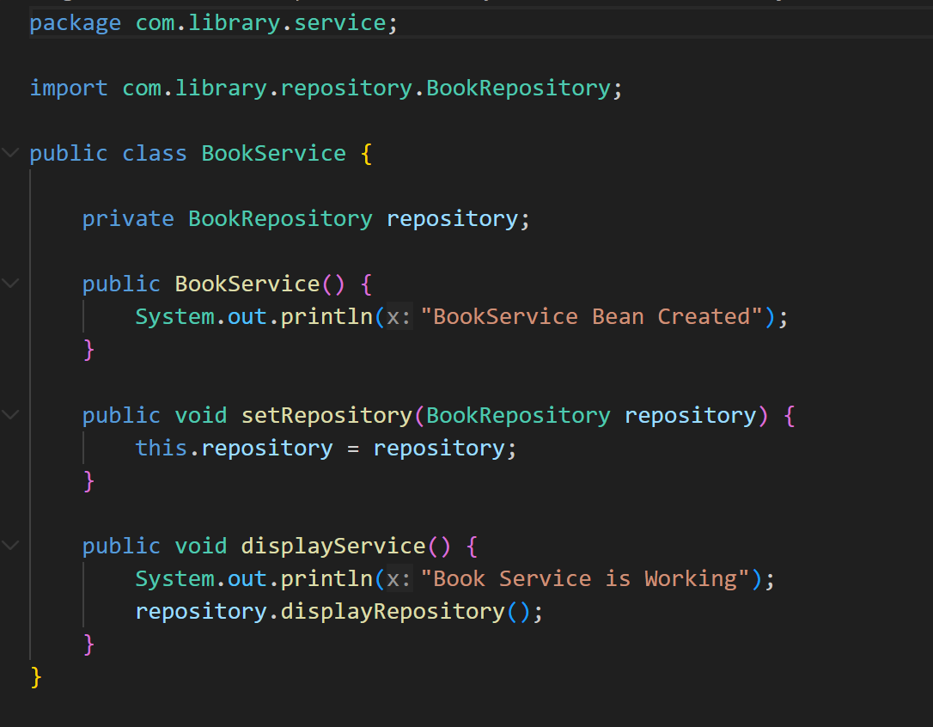
src/main/java/com/library
MainApp.java
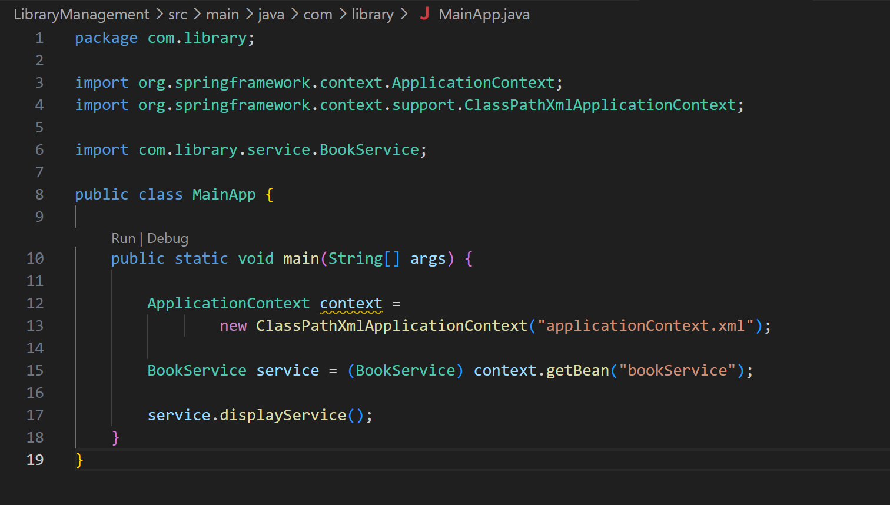

src/main/resources
applicationContext.xml
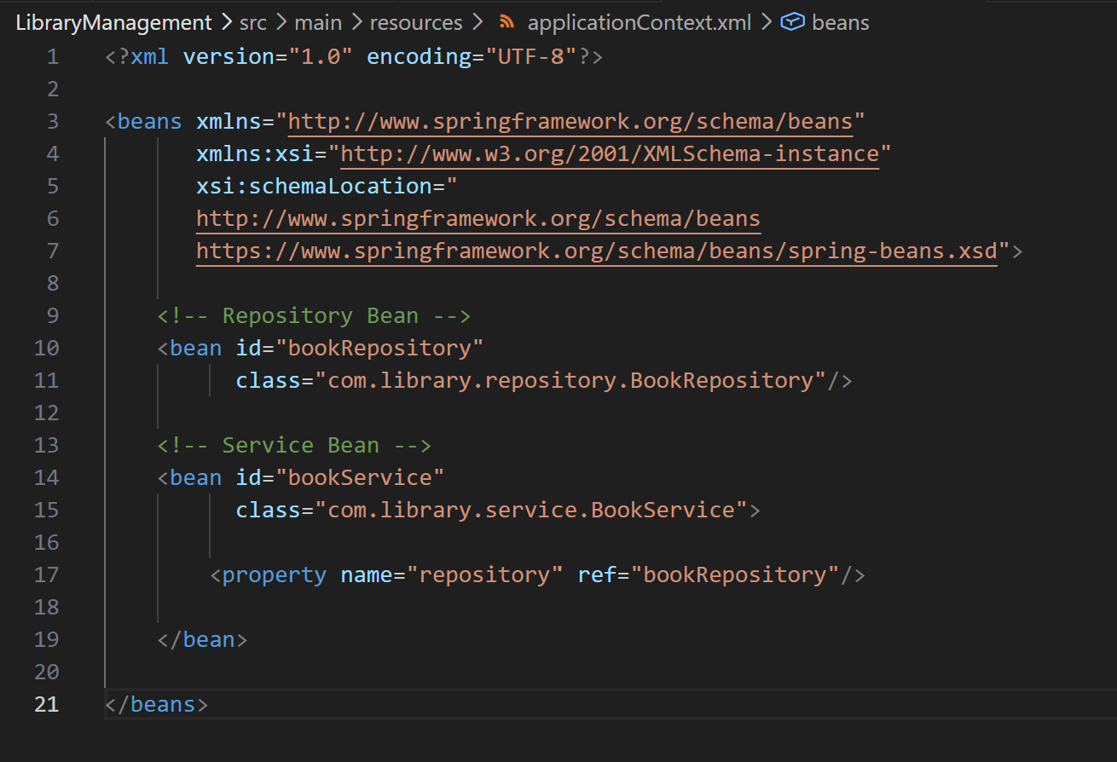
OUTPUT-
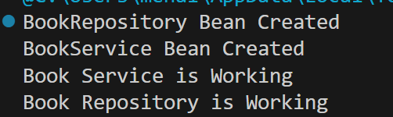

Exercise 2: Implementing Dependency Injection
Scenario:
In the library management application, you need to manage the dependencies between the BookService and BookRepository classes using Spring's IoC and DI.

src/main/resources
applicationContext.xml


src/main/java/com/library/service
BookService.java


src/main/java/com/library/repository
BookRepository.java


src/main/java/com/library
MainApp.java


OUTPUT-


Exercise 4: Creating and Configuring a Maven Project
Scenario:
You need to set up a new Maven project for the library management application and add Spring dependencies.

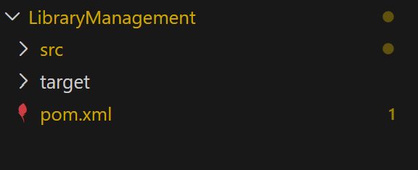

pom.xml
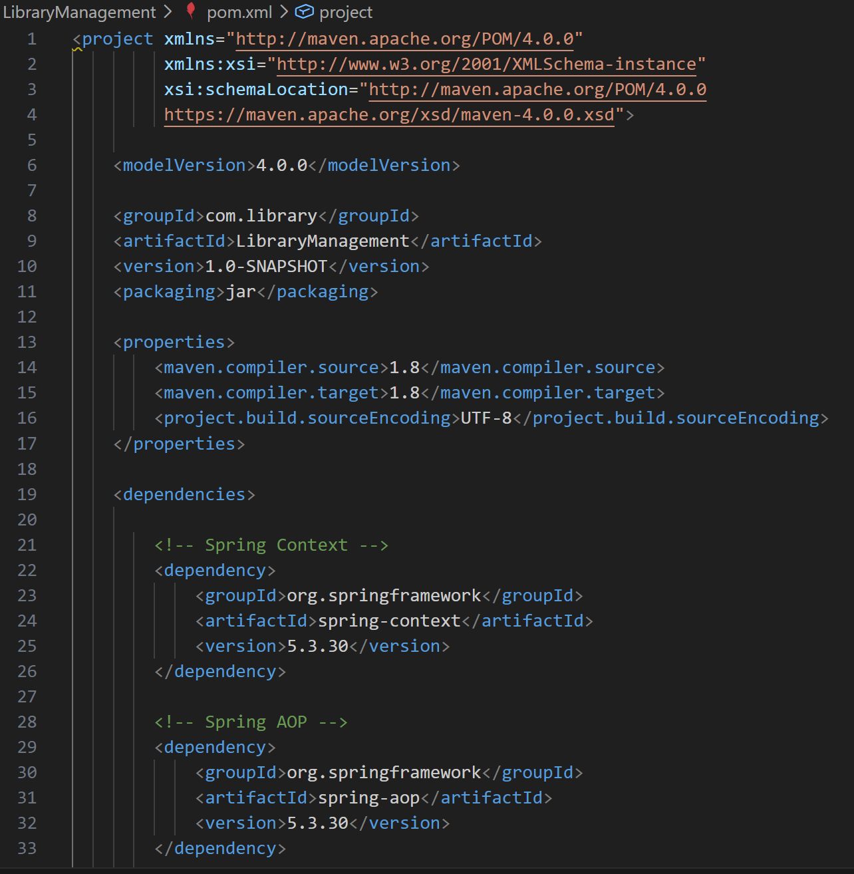
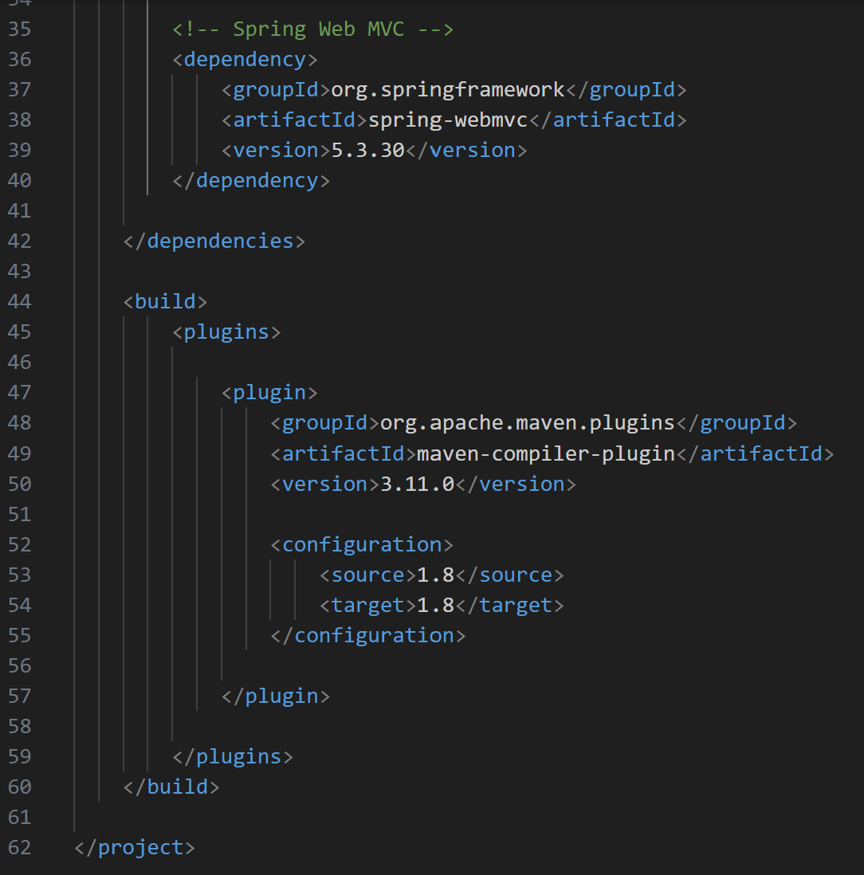

OUTPUT-
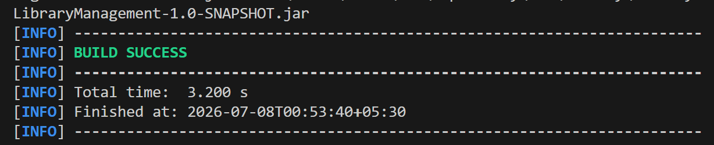

SPRING DATA JPA WITH HIBERNATE
Spring Data JPA - Quick Example
Create a Eclipse Project using Spring Initializr

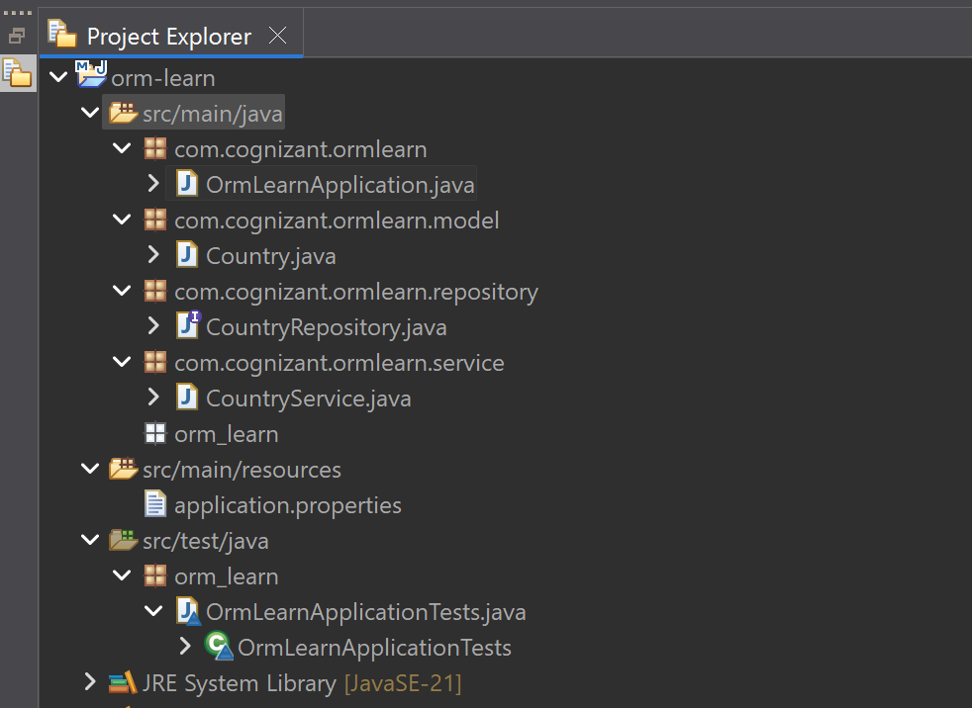

application.properties
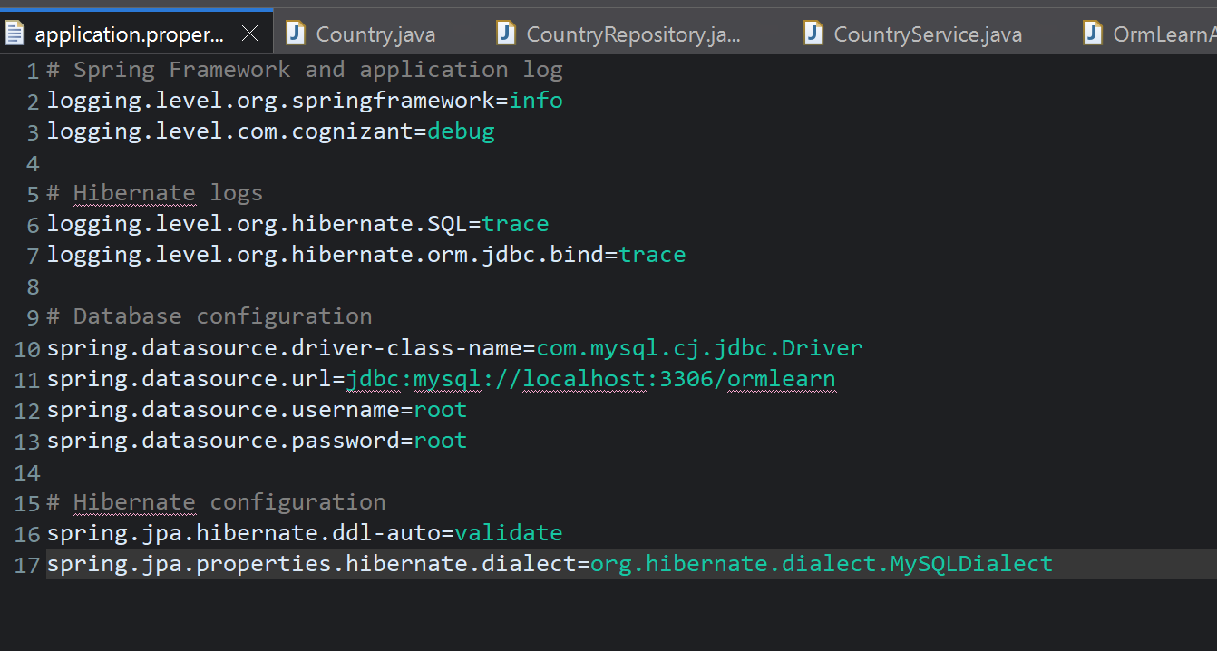
Country.java
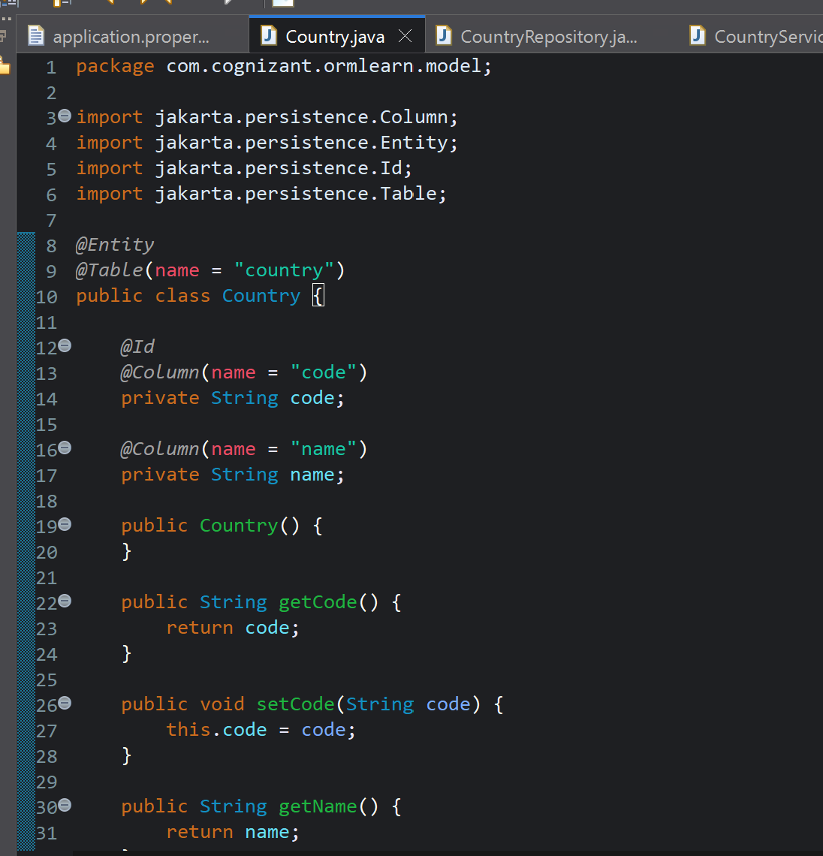

CountryRepository.java
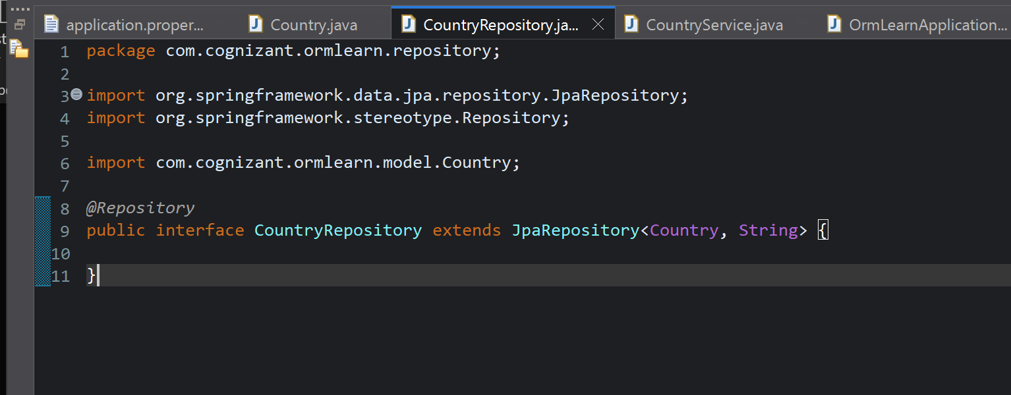

CountryService.java
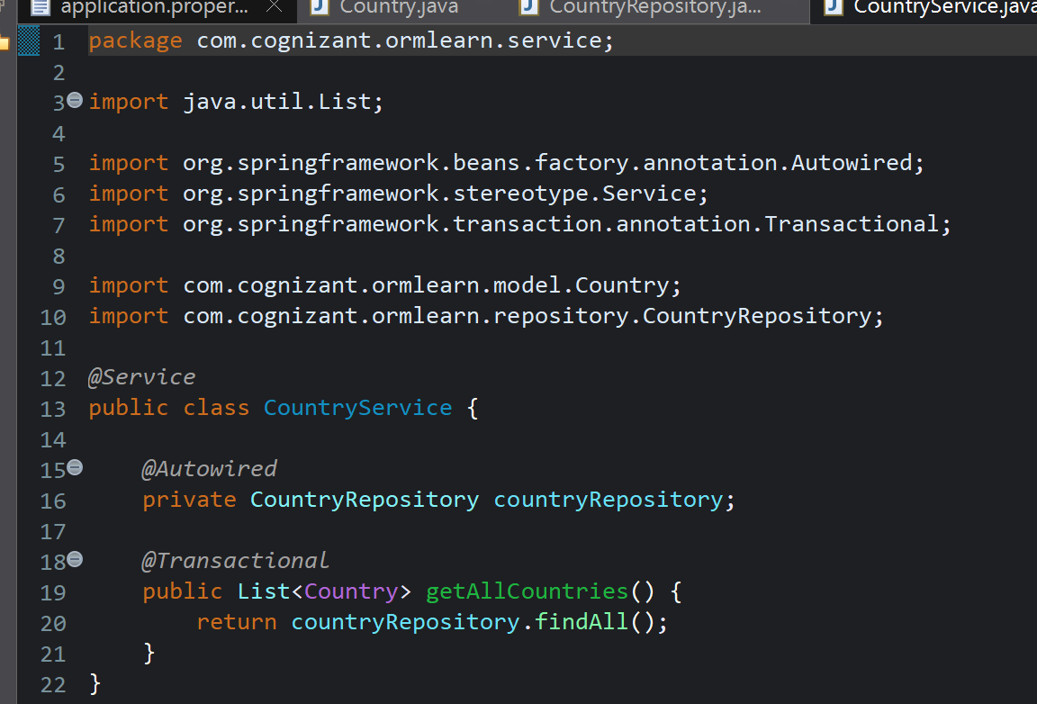

OrmLearnApplication.java
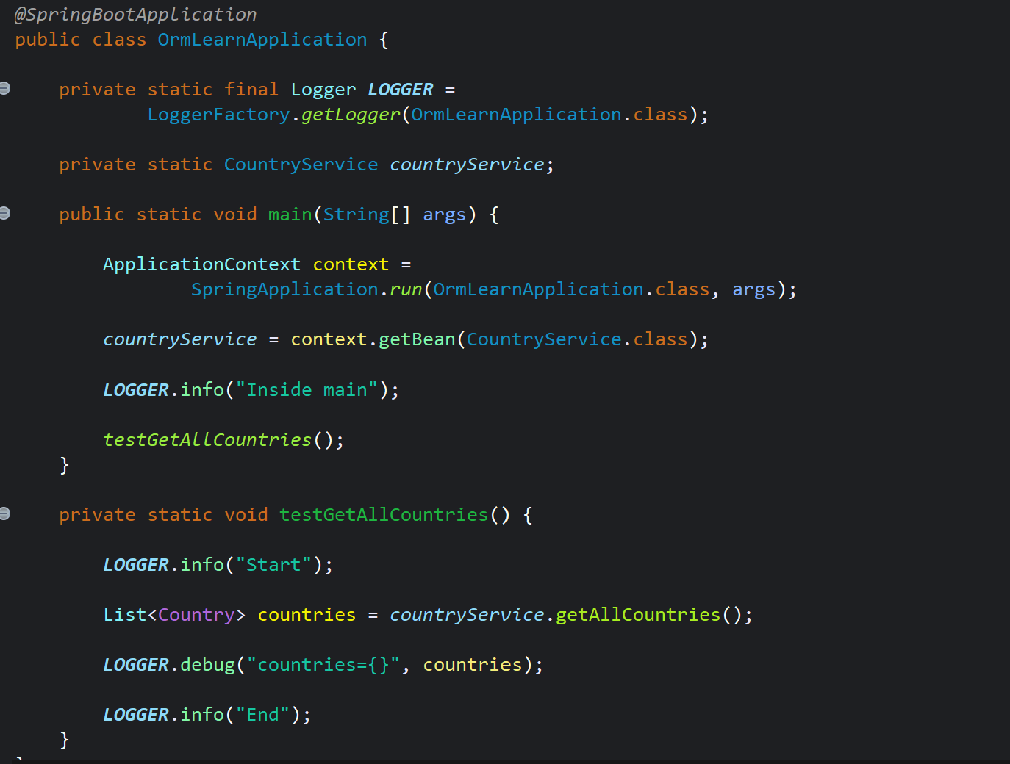
MYSQL Workbench
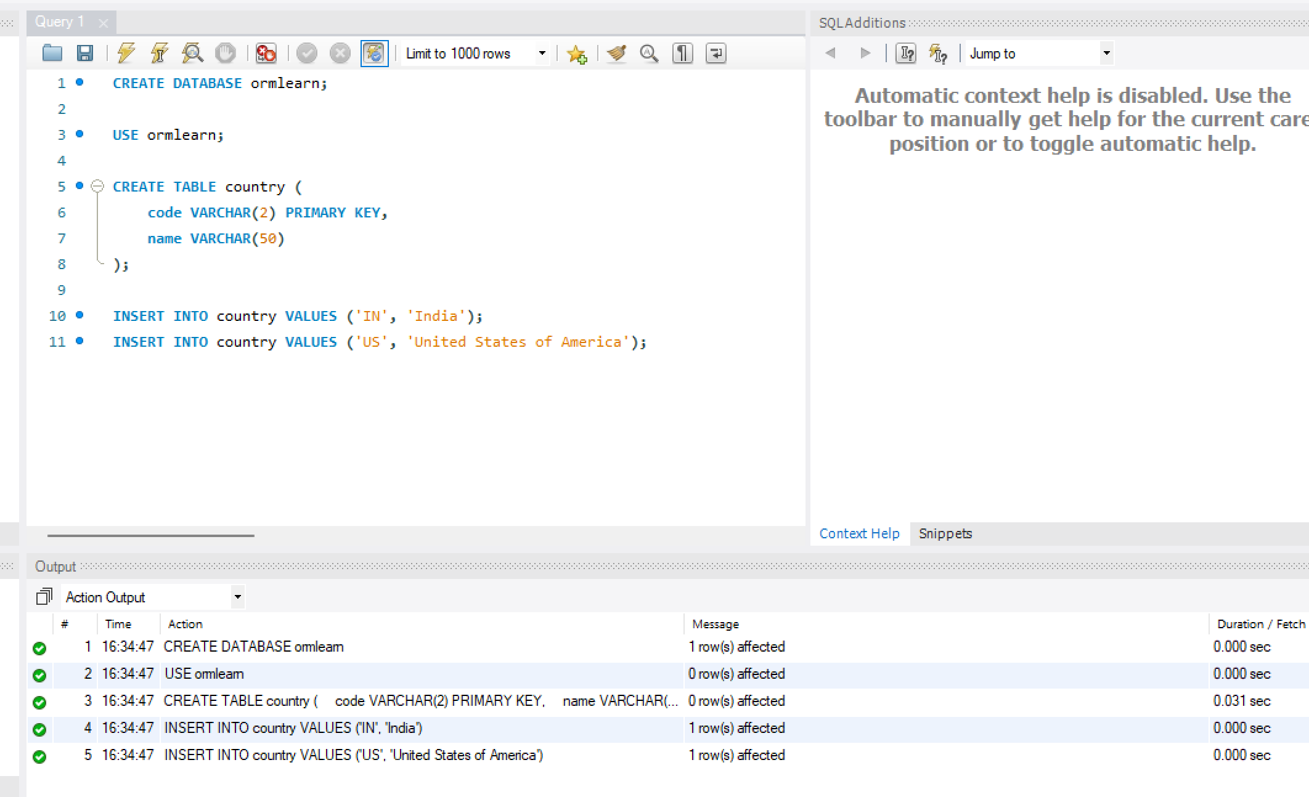

OUTPUT-
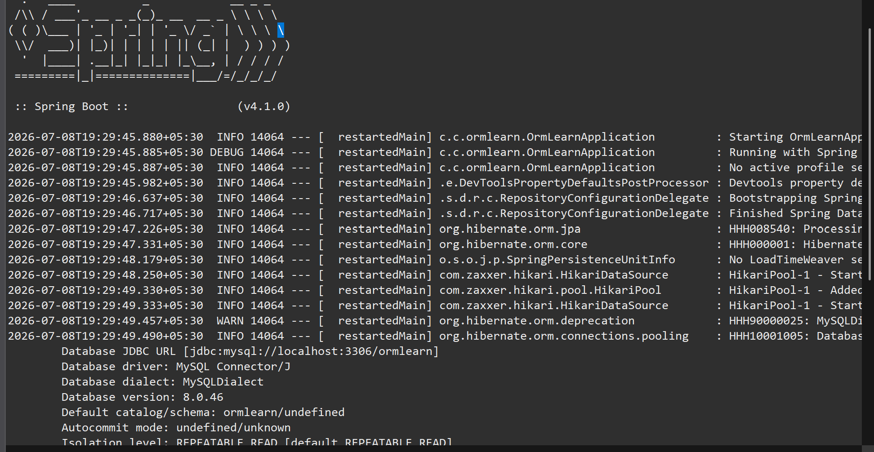
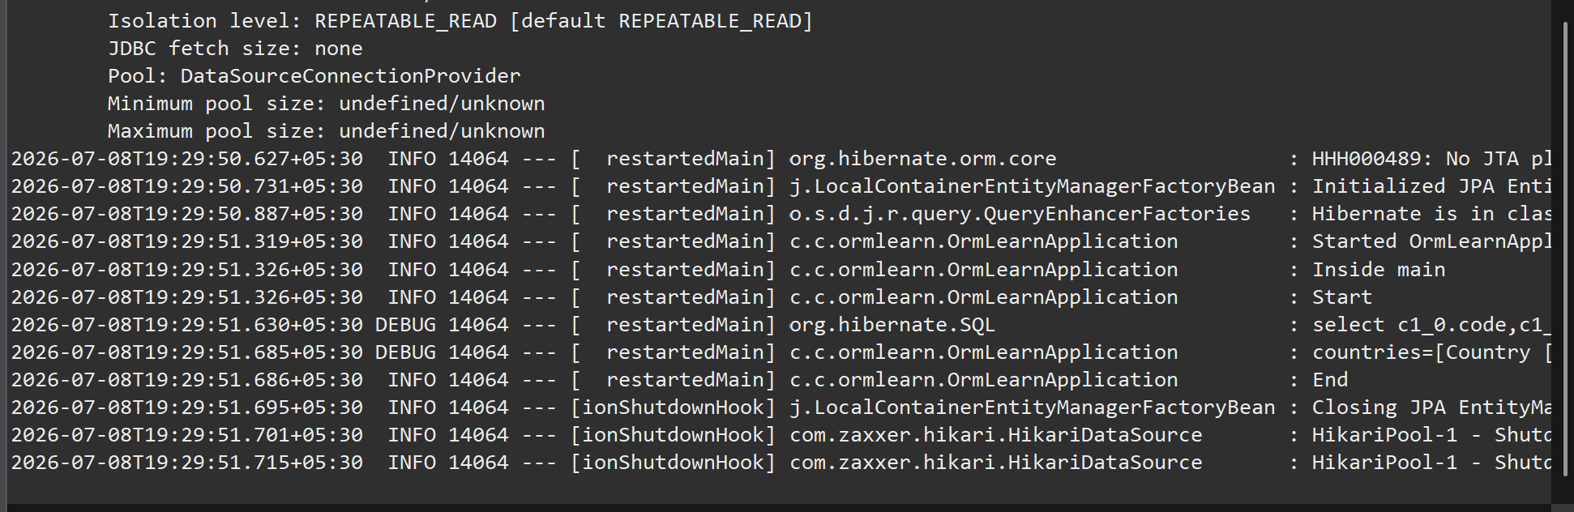

Difference between JPA, Hibernate and Spring Data JPA
Feature | JPA | Hibernate | Spring Data JPA
Type | Specification | ORM Framework | Spring Framework Module
Purpose | Defines standards for persistence | Implements JPA and provides ORM functionality | Simplifies database operations using JPA
Implementation | No | Yes | No (uses JPA implementation like Hibernate)
Boilerplate Code | More | Moderate | Very Less
Transaction Management | Not provided | Manual | Automatic using @Transactional
Repository Support | No | No | Yes (JpaRepository)
Query Methods | No | HQL/Criteria API | Derived query methods and JPQL
Dependency | Needs an implementation | Can work independently | Depends on JPA implementation (Hibernate)

Architecture-
Application
│
▼
Spring Data JPA
│
▼
JPA (Specification)
│
▼
Hibernate (Implementation)
│
▼
MySQL Database

Explanation
1. Java Persistence API (JPA)
- JPA is a specification (JSR 338).
- It defines rules for mapping Java objects to database tables.
- It does not contain any implementation.
- It requires an implementation such as Hibernate.

2. Hibernate
- Hibernate is an ORM (Object Relational Mapping) framework.
- It is one of the most popular implementations of JPA.
- It converts Java objects into database records and vice versa.
- It manages sessions and transactions.

3. Spring Data JPA
- Spring Data JPA sits on top of JPA.
- It reduces boilerplate code.
- It automatically creates implementations for repository interfaces.
- It provides CRUD methods like save(), findAll(), delete(), etc.
- It supports automatic transaction management using @Transactional.

Conclusion
- JPA is a specification that defines persistence standards.
- Hibernate is an ORM framework that implements JPA.
- Spring Data JPA is a Spring module that simplifies JPA by reducing boilerplate code and providing repository support with automatic transaction management.

